**PIZZA SALES SQL QUERIES**

**A: KPI**

**1.Total Revenue :**

select SUM(total_price) AS Total_Revenue from pizza_sales

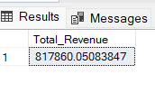

**2. Average Order Value:**

select SUM(total_price) / count(DISTINCT order_id) as Avg_Order_Value from pizza_sales

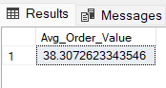

**3.Total Pizza Sold :**

select sum(quantity) as Total_Pizza_Sold from pizza_sales

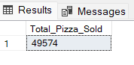

**4.Total Orders:**

select count(distinct order_id) as Total_Orders from pizza_sales

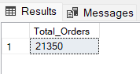

**5.Average Pizzza Per Order:**

SELECT CAST(CAST(SUM(quantity) AS DECIMAL(10,2)) /

CAST(COUNT(DISTINCT order_id) AS DECIMAL(10,2)) AS DECIMAL(10,2))

AS Avg_Pizzas_per_order

FROM pizza_sales

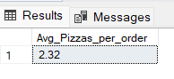

6.**Total Pizza name in Menu Card**

SELECT DISTINCT pizza_name

FROM pizza_sales;

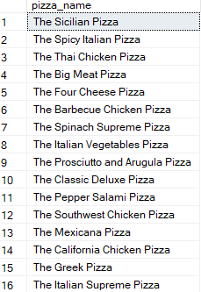

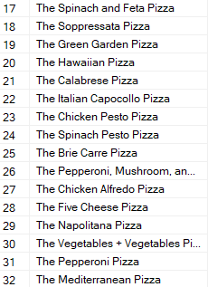

**B.DAILY TREND FOR TOTAL ORDERS**

SELECT DATENAME(DW, order_date) AS order_day, COUNT(DISTINCT order_id) AS total_orders

FROM pizza_sales

GROUP BY DATENAME(DW, order_date)

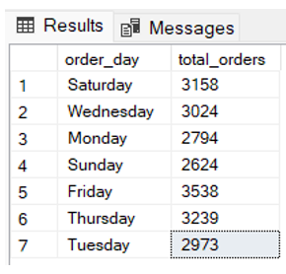

**C.MONTHLY TREND FOR ORDERS**

select DATENAME(MONTH, order_date) as Month_Name, COUNT(DISTINCT order_id) as Total_Orders

from pizza_sales

GROUP BY DATENAME(MONTH, order_date)

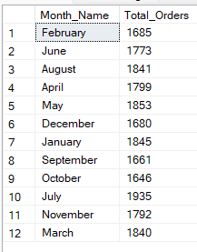

**D. PERCENTAGE OF SALES BY PIZZA CATRGORY**

SELECT pizza_category, CAST(SUM(total_price) AS DECIMAL(10,2)) as total_revenue,

CAST(SUM(total_price) * 100 / (SELECT SUM(total_price) from pizza_sales) AS DECIMAL(10,2)) AS PCT

FROM pizza_sales

GROUP BY pizza_category

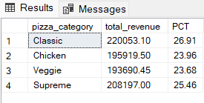

E.Percentage of Sales by Pizza Size

SELECT pizza_size, CAST(SUM(total_price) AS DECIMAL(10,2)) as total_revenue,

CAST(SUM(total_price) * 100 / (SELECT SUM(total_price) from pizza_sales) AS DECIMAL(10,2)) AS PCT

FROM pizza_sales

GROUP BY pizza_size

ORDER BY pizza_size

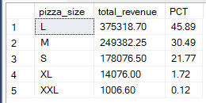

F.Total Pizza Sold By Pizza Category

SELECT pizza_category, SUM(quantity) as Total_Quantity_Sold

FROM pizza_sales

GROUP BY pizza_category

ORDER BY Total_Quantity_Sold DESC

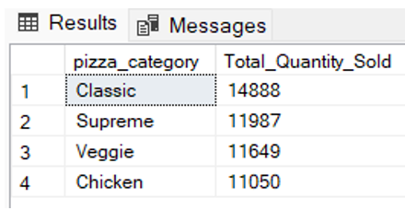

**G.TOP 5 PIZZAS BY REVENUES :**

SELECT Top 5 pizza_name, SUM(total_price) AS Total_Revenue

FROM pizza_sales

GROUP BY pizza_name

ORDER BY Total_Revenue DESC

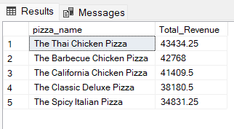

**H.BOTTOM 5 PIZZAS BY REVENUE**

SELECT Top 5 pizza_name, SUM(total_price) AS Total_Revenue

FROM pizza_sales

GROUP BY pizza_name

ORDER BY Total_Revenue ASC

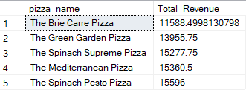

**I.TOP 5 PIZZAS BY QUANTITY**

SELECT Top 5 pizza_name, SUM(quantity) AS Total_Pizza_Sold

FROM pizza_sales

GROUP BY pizza_name

ORDER BY Total_Pizza_Sold DESC

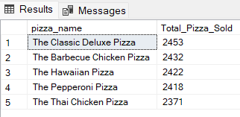

**J.BOTTOM 5 PIZZAS BY QUANTITY**

SELECT TOP 5 pizza_name, SUM(quantity) AS Total_Pizza_Sold

FROM pizza_sales

GROUP BY pizza_name

ORDER BY Total_Pizza_Sold ASC

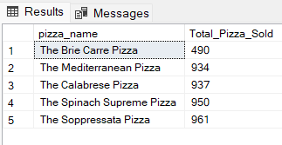

**K.TOP 5 PIZZAS BY TOTAL ORDERS**

SELECT Top 5 pizza_name, COUNT(DISTINCT order_id) AS Total_Orders

FROM pizza_sales

GROUP BY pizza_name

ORDER BY Total_Orders DESC

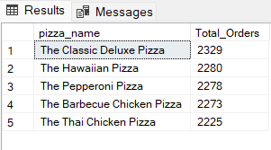

L.BOTTOM 5 PIZZAS BY TOTAL ORDERS

SELECT Top 5 pizza_name, COUNT(DISTINCT order_id) AS Total_Orders

FROM pizza_sales

GROUP BY pizza_name

ORDER BY Total_Orders ASC

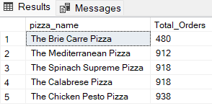

NOTE:

If you want to apply the pizza_category or pizza_size filters to the above queries you can use WHERE clause. Follow some of below examples

SELECT Top 5 pizza_name, COUNT(DISTINCT order_id) AS Total_Orders

FROM pizza_sales

WHERE pizza_category = 'Classic'

GROUP BY pizza_name

ORDER BY Total_Orders ASC